P.5 INTEGRATED SCIENCE TOPICAL BREAKDOWN
Theme: Science in human activities and occupations
Topic: Keeping poultry and bees
Sub-topics:
- Terms used in poultry keeping
- Types of poultry
- Reasons for keeping poultry
- External features of a domestic fowl (male & female)
- Functions of each part of a domestic fowl
- Physical differences between a male and a female chicken
- Types of feathers
- Importance of feathers to birds and man
- Types of chicken
- Definitions:
- Type of chicken
- Layers
- Broilers
- Dual purpose
- Examples of each type
- Breeds of chicken
Definitions
- Breeds of chicken
- Local breed
- Exotic breed
- Cross breeds
- Hybrids
- Examples of each breed of chicken
- Characteristics of each breed
- Comparing local and exotic breeds
- Poultry keeping
- Advantages

- Management of poultry
- Feeding:- Types of mash
- Feeding equipment
- Classes of food needed in the bird’s diet
- Reasons for feeding poultry
- Good feeding of fowl
- Digestive system of a fowl
- Diagram
- Functions
- Egg formation
- Fertilizatiom
- reproductive system of a hen
- Internal structure of an egg
- Egg candling
- Incubation
- Definition (incubation & incubation period)
- Conditions necessary for eggs to hatch
- Incubation periods of different birds
- Qualities of eggs to be incubated
- Factors that may prevail an egg to hatch
- Types of incubation (Natural & artificial)
- Advantages and disadvantages of each type of incubation
- Incubators
- Brooding
- Definition
- Types of brooding
- Advantages and disadvantages of brooding
- Types of brooders
- Poultry vices
- Causes of poultry vices (general)
- Examples of poultry vices
- Definition and control of each vice
- Parasites and diseases of poultry
- Examples of parasites and poultry diseases
- Signs and symptoms of poultry diseases
- Prevention and control of poultry diseases
- Types of parasites
- Examples of each type of parasites
- Prevention and control of parasites and diseases
- Effects of parasites and poultry diseases

- Proper management practices in poultry
- Farm records
- Types of farm records kept on a poultry farm
- Importance of keeping farm records
- Factors to consider when starting a farm
APICULTURE
- Terms used in bee keeping
- Social and solitary insects
- Examples of social and solitary insects
- Characteristics of insects
- Types (casts) of bees
- Structure of each cast
- Duties/roles of each type
- External parts of a honey bee
- Functions of each part of a honey bee
- Life history of a honey bee
- Swarming (definition)
- Reasons why bees swarm
- Methods of preventing swarming
- Types of hives
- Examples of each type of bee hives
- Advantages and disadvantages of each type of bee hive
- Comparing traditional and modern bee hives
- Siting a bee hive (definition)
- Factors to consider when siting a hive
- Stocking a hive (definition)
- Methods of stocking a hive
- Honey harvesting
- Methods of honey harvesting
- Equipments used when handling bees
- Occasions when a bee keeper handles bees
- Honey extraction (definition)
- Method of honey extraction
- Modern extraction
- Products of bees
- Importance of bees to people and plants
- feeding of bees
- Enemies of bees
- Ways of preventing and controlling of bee enemies

TOPIC 2
Theme: Matter and energy
Topic: Measurements
Sub-topic:
- Measuring (definition)
- Length (definition)
- Units for measuring length
- Materials used to measure length
- Converting length to different units
- Area (definition)
- Calculating area
- Mass and weight (definitions): units
- Comparing mass and weight
- Equipments used for measuring weight and mass
- Volume (definition)
- Capacity
- Basic units for measuring capacity and volume
- Types of objects
- Examples of type of objects
- Calculating volume of objects
- Density (definition)
- Basic units for measuring density
- Calculating density of objects
- Relationship between density, mass and volume
- Behaviour of objects
- Sinking and floating objects

TOPIC 3
Theme: Human Health
Topic: Immunisation
Sub-topic:
- Immunity (definition)
- Types of immunity
- Ways of acquiring each type of immunity
- Importance of immunity
- Immunisation (definition)
- Vaccinations
- Antibodies
- Types of vaccines
- UNEPI and its roles
- The infant/childhood killer diseases
- The causes, sign and symptoms of each disease
- Effects of immunisable diseases to infants
- Immunisation sites and schedules
- Importance of immunisation
- Roles of individuals, families and communities in immunisation
- Other immunisable diseases

- Child health card/immunisation card
- Contents of an immunisation card
- Importance of a child health card to be doctor and parents

TOPIC 4
Theme: The human body
Topic: Digestive system
Sub-topic
- - Digestive system (definition)
- Digestion
- Alimentary canal
- Types of digestion
- Enzymes (definition)
- Examples of enzymes
- Characteristics of enzymes
- - The structure of the human digestive system
- Functions of each part of the digestive system
- Diseases and disorders of the digestive system
- Ways of caring for the digestive system

TOPIC 5
Theme: The Environment
Topic: Components of the environment
Sub-topic:
- - Soil
- Terms of related to soil
- Types of soil
- Characteristics of each type of soil
- Uses of each type of soil
- - Components of soil
- Importance of each component of soil
- Experiments to show each component of soil
- Soil formation
- Soil drainage and capillarity
- - Soil erosion (definition)
- Types of erosion
- Causes of erosion
- Agents of erosion
- Effects of soil erosion
- Control of soil erosion/soil conservation
- - Soil fertility (definition)
- Ways of improving soil fertility
- Types of fertilisers
- Examples of types of fertilisers
- Advantages and disadvantages of fertilizers

- - Soil pollutants (definition)
- Soil pollution
- Causes of soil pollution
- Effects of soil pollution
- - Soil exhaustion
- Causes of soil exhaustion
- Prevention of soil exhaustion

TOPIC 6
Theme: Science in human activities and occupation
Topic: Crop growing
Sub-topic:
- - Types of crops
- Tuber crops
- Legume crops
- Vegetable crops
- Cereal crops
- Fruit crops
- - Tuber crops
- Types of tuber crops
- Examples of tuber crops
- Growing and caring fir tuber crops
- Propagation of tuber crops
- Common pests and diseases of tuber crops
- Characteristics of common tuber crop pests
- Effects of pests and diseases to tuber crops
- Methods of controlling pests and diseases
- - Leguminous crops
- Examples of legume crops
- Characteristics of legume crops
- - Cereal crops
- Examples of cereals
- Characteristics of cereal crops
- Fruit crops
- Vegetable crops
- - Nursery bed
- Advantages of a nursery bed
- Crops grown in a nursery bed
- How to care for crops in a nursery bed
- Transplanting
- Crop growing practices
- Garden tools
- Common garden tools and their uses
- Caring for garden

Theme: Matter and energy
Topic: Heat energy
Sub-topic:
- - Matter (definition)
- Weight and mass
- States and examples of matter
- Properties of matter
- Characteristics of each state of matter
- Changes in states of matter
- - Mixtures (definitions)
- Solution
- Solvent
- Solutes
- Types of mixtures
- Examples of mixtures
- - Separation of mixtures
- Separation of mixtures of solids and liquids
- Separating mixtures of liquids
- Separating mixtures of solids
- Diffusion, dilution and alloys
- - Work, force and energy (definitions)
- Calculating work done
- - Friction (definition)
- Types of friction
- Advantages and disadvantages of friction
- methods of reducing and increasing friction

- Gravity, Buoyancy and inertia forces
- - Energy (definition)
- Types of energy
- Examples of each type of energy
- - Energy interconversion (illustrations)
- Forms of energy
- - Heat energy
- Sources of heat energy
- Uses of heat energy
- Dangers of heat energy
- - Heat transfer
- Conduction
- Convection illustrations
- Radiation
- Comparison of heat transfer
- - Conductors and insulators
- Examples of conductors
- uses of conductors
- Uses of insulators
- Application of insulators in our daily life
- - Heat reflectors and absorbers
- Vacuum flask
- - Expansion in liquids
- Expansion in gases
- Effects of expansion and contraction in matter
- - Temperature
- Types of temperature scales
- Types of thermometers
- - Liquids used in thermometers
- Reasons why mercury is commonly used in thermometers
- Advantages of suing alcohol over mercury
- Disadvantages of using water in thermometers
- Temperature conversion
- Converting Fahrenheit to Celsius scale
- - Burning and rusting
- Burning
- Candle flame
- Experiments to show that burning needs oxygen
- Putting out fire
- - Rusting
- Causes of rusting (conditions) and experiments
- Disadvantages of rusting
- Methods of preventing rusting

Theme: The world of living things
Topic: Bacteria and Fungi
Sub-topics
- Bacteria
- Places where bacteria are found
- Reproduction in bacteria
- Types of bacteria
- Nature of bacteria
- Useful bacteria and their examples
- Advantages of useful bacteria
- Harmful bacteria and their examples
- Nature of living (aerobic bacteria and anaerobic bacteria)
- - Prevention and treatment of bacterial diseases
- Antibiotics
- Fungi
- Description of fungi
- Examples of fungi
- Structure of a mushroom – parts and functions
- Nature of fungi
- Useful and harmful fungi
- Advantages and disadvantages of fungi
- Prevention and control of dangers caused by harmful fungi
- Comparing fungi and bacteria
- Similarities
- Differences
- Fighting fungal and bacterial diseases
- Pioneers of science

Theme: Science in human activities and occupation
Topic: Keeping goats, sheep and pigs
Sub-topic:
- Keeping goats
- External parts of a goat
- Uses of goats
- Advantages of rearing goats over other animals
- Breeds of goats
- Types of breeds
- Examples of each breed
- Characteristics of local and exotic breeds of goats
- Advantages of keeping local breeds over exotic and vice versa
- Housing and management of goats
- Housing for goats
- Importance of housing goats
- Grazing goats
- Free range grazing
- Tethering grazing
- zero grazing
- Advantages and disadvantages of each grazing method
- - Gestation period in goats (reproduction in goats)
- Products of goats
- Diseases and parasites in goats
- Control of diseases and parasites in goats
- Rearing sheep
- External parts of a sheep
- Reasons for rearing sheep
- Breeds of sheep
- Local breeds
- Examples and characteristics of local breeds
- Exotic breeds
- Examples and characteristics of exotic breeds of sheep
- Advantages of rearing local breeds over exotic breeds of sheep and vise versa
- Management of sheep
- Feeding sheep/grazing sheep
- Shearing
- Docking
- Advantages of docking in sheep
- - Gestation period in sheep
- Lambing
- Diseases and parasites in sheep
- Control and prevention of diseases and parasites in sheep
- Rearing pigs
- Terms used in pigs rearing
- External parts of a pig
- Why people rear pigs
- Breeds of pigs
- Local breeds and examples
- Characteristics of local breeds of pigs
- Exotic breeds of pigs
- Examples of characteristics of exotic breeds of pigs
- - Factors to consider when selecting a good piglet for rearing
- Systems of rearing pigs
- Advantages and disadvantages of each system
- Reproduction in pigs
- Heat period
- Signs of heat in pigs
- Caring for pregnant sow
- Gestation period
- Steaming up in pigs
- Management practices in pigs
- Castration
- Methods of castration
- Advantages and disadvantages of castration
- Weaning piglets
- feeding piglets
- Diseases and parasites in pigs
- Signs of good health in animals
- Signs of sickness in animals
- Causes of diseases in animals
- Examples of diseases in piggery
- Prevention and control of diseases in pigs
- Parasites in pigs
- Types of parasites
- Examples of parasites
- Controlling and preventing parasites
- Keeping records on the farm
- Definition of a farm record
- Types of farm records
- Importance of keeping records on the farm

Theme: Human Health
Topic: Food and Nutrition
Sub-topics:
- - Definition of food, feeding, nutrition, nutrients
- Types of nutrition
- Reasons for eating food (5Hs)
- Uses of food in the body
- Food taboos and food beliefs
- Definition of food taboo and food belief
- Examples of food taboos and food beliefs
- Advantages and disadvantages of food taboos

- Breast feeding and bottle feeding
- Definition of breast feeding and bottle feeding
- Advantages and disadvantages of breast feeding and bottle feeding
- Groups of vulnerable people
- Definition of vulnerable
- Examples of groups of vulnerables
- Caring for vulnerables (food for vulnerable groups of people)
5-7 Malnutrition and deficiency diseases
- Definition of malnutrition, deficiency diseases
- Symptoms of malnutrition in adults
- Examples of deficiency diseases
- causes of each deficiency disease
- Signs and symptoms of each deficiency disease
- Prevention of deficiency diseases

Theme: Managing changes in environment
Topic: Changes in environment
Sub-topics:
- Types of changes
- Biological changes
- Examples of biological changes in plants and animals
- Characteristics of biological changes
- Physical changes
- Examples of physical changes
- Characteristics of chemical changes
- - Natural changes and man-made changes
- Examples of natural and man-made changes
- Consequences of various types of changes

Theme: Human Health
Topic: PHC
Sub-topics:
- - Definition of PHC
- Elements of PHC
- Principles of PHC
- - Responsibilities of individuals, families and the community in health promotion.
- Suitable lifestyles and good health practices for promoting PHC

PRIMARY FIVE INTEGRATED SCIENCE LESSON NOTES
TERM I - 2026
TOPICS AND TO BE TAUGHT IN TERM ONE.
- Poultry and bee keeping (Science in human activities and occupations)
- Measurements (matter and energy)
- Immunization and immunity (human health)
- Digestive system (human body)
- Soil (components of the environment)
- Crop growing

TOPIC 1: POULTRY
Poultry are domestic birds/fowls
Poultry keeping is the rearing of domestic birds/fowls.
Examples of poultry/fowls
- Chicken - Turkey
- Pigeons - Ducks
- Guinea fowls - Geese
Reasons why people rear poultry
- They are a source of income when sold.
- They provide meat and eggs/They are kept for meat and egg production.
- Poultry are used in cultural practices like paying dowry, rituals and sacrifices.
- Some are kept as pets
- Their droppings/dung is used as manure in gardens.
- Their feathers are used of decorations, making pillows and as costumes in traditional dances.
Terms used in poultry management.
Hen – An adult female chicken
Cock - An adult male chicken
Chick - A very young chicken below 8 weeks.
Layer - A type of chicken kept for egg production.
Broiler - A type of chicken kept for meat production.
Dual purpose - A type of chicken kept for both meta and eggs.
Cockerel - A young male chicken/young cock.
Pullet - A young female chicken/young hen.
Capon - A castrated cock.
Culling - The removal of sick and unproductive birds from the flock.
Moulting in birds - The process by which birds shed off their old feather.
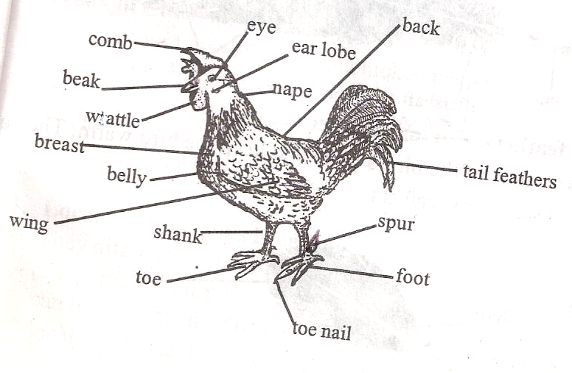
External parts of a cock.

Functions of some parts of a cock.
Spur - It is used for protection against enemies.
Beak - Used to pick food and also protection.
Claws/Toe nails- Protection against enemies.
Nostril - Smelling and breathing.
Wing - For flying.
Feathers - Covering the body of birds.
Eye - For seeing/sight
Birds legs covered by claw scales.
Physical differences between a cock and a hen.
- A cock has a bigger comb while a hen has a small ones.
- A cock has a bigger wattle while a hen has a small wattle.
- A cock has a long spur while a hen has a short spur.
- A cock has bright colour feathers while a hen has dull coloured feathers.
Feathers are structures that cover the bird’s body.
Uses of feathers to birds.
- Feathers enable the birds to fly.
- Feathers give birds colour for identification.
- They cover the bird’s body from danger.
- They keep the bird’s body warm by preventing heat lose.
Types of feathers.
- Quill feathers(flight feathers)
- Body feathers (covert feather)
- Filoplume feathers (hair feathers)
- Down feathers
Quill feathers
- They are the biggest feathers on the bird’s body.
- They are found on wings and tails.
- They help birds to fly, that is why they are called flight feathers.
Part of a quill feather.
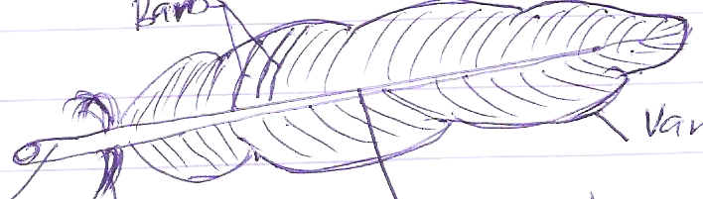
vane
Barbs
Quill
Shaft/Ranchis

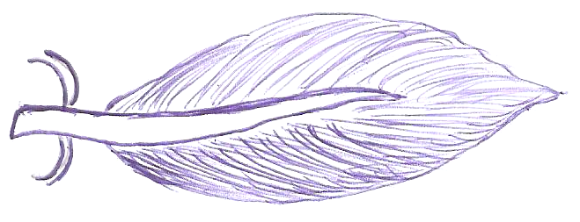
Covert feathers
- They cover the biggest part of the bird’s body.
- They keep the bird’s body warm.
- They are the second largest feathers on a bird.
Down feather
- These are mainly found on the belly/abdomen of a bird.
- They are the first to appear on a chick.
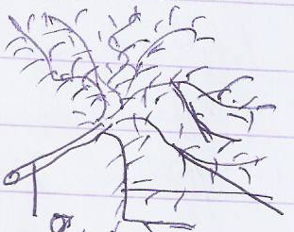
- They have loose barbs which makes them soft like cotton wool.

Filoplume feathers
- These are the tinnest/smallest feathers.
- They are hair like and nearest to the skin of a bird.
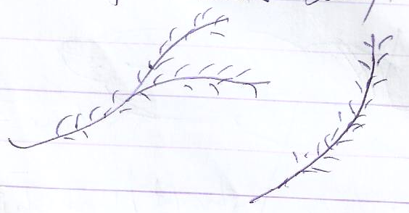
- They can be seen clearly after removing all the bigger feathers from bird’s body.

BREEDS OF CHICKEN
A breed of chicken is a group of birds having the same origin, similar features and characteristics.
There are four breeds of chicken i.e,
- Exotic breeds
- Local breeds/indigenous breeds
- Cross breeds
- Hybrids.
Local breeds
Are birds which have their origin in Africa.
These are breeds which have lived in Africa for a very long time/breeds whose origin is Africa.
Characteristics of local breeds
- They have different colours, shape and size.
- They have a low growth rate/grow slowly.
- They are small in size and lay few eggs.
- They can incubate their eggs and hatch chicks.
- Local breeds are not bred for a particular purpose (dual purpose).
Advantages of keeping local breeds.
- They are resistant to diseases.
- They can survive in harsh conditions/weather.
- Local breeds produce high quality meat and eggs.
- They can incubate eggs and hatch them.
- Local breeds can feed on their own and don’t need a lot of attention and care.
Exotic breeds
These are breeds which were imported from outside countries like, USA, Germany, Spain, Italy, England, etc.
Characteristics of exotic breeds.
- They have the same colour, shape, and sizes.
- They grow and mature quickly.
- They lay many eggs and produce a lot of meat.
- Exotic breeds produce young ones which resemble each other.
- They have the same ancestors.
Disadvantages of keeping exotic breeds.
- They require a lot of attention and care.
- They can easily fall sick so they are not resistant to disease.
- They produce low quality meat and eggs.
- They can’t incubate their eggs and hatch them.
Examples of exotic breeds.
- Plymouth rock - Rhode island red
- White leghorn - Black aunstralop
- New Hampshire - Micorca
- Light Sussex - Ancona
- Brown egger - Cornish white and Cornish dark.
- Jersey black giant - Sykes.
Characteristics of some exotic breeds of chicken.
- White leghorn.
- It originated from Italy.
- It has yellow legs and beak.
- It is a good layer.
- It is white in colour.
- Rhode island red
- They originated from America.
- They have dark red blown feathers.
- They have yellow legs and skin.
- A cock weighs 4 kg while a hen 3kg.
- Light Sussex
- They originated from England
- They are white in colour.
- They are good table birds.
- New Hampshire
- It originated from America.
- It is light red in colour.
- It is a dual purpose breed.
Cross breeds
This is a breed got after mating a local breed with an exotic breed.
Local breeds of chicken can be improved upon by cross breeding.
Hybrids
This is a breed got after mating two exotic breeds, i.e white leghorn and Plymouth rock.
It is done to upgrade the exotic breeds.
Examples of hybrids
Thumper 404, Thumper 707, Sterling, Ross birds, Hiline stock, Shavers.
Types of chicken
A type of chicken is a class of birds kept for a particular /specific purpose.
There are three types of chicken i.e,
Layer - A type of chicken kept for egg production.
Broiler - A type of chicken kept for meat production.
Dual purpose- A type of chicken kept for both meat and egg production.
Examples of exotic breeds which are layers (light breeds)
- White leghorn
- Brown egger
- Ancona
Examples of exotic breed which are broilers (heavy breeds)
- Light Sussex
- Plymouth rock
- Cornish white and Cornish dark
- Jersey black giant.
Examples of exotic breeds which are dual purpose.
- Rhode island red
- Black aunstralop
- New Hampshire
FEEDING IN POULTRY
Reasons why we feed poultry.
- They are fed to grow well.
- To lay many eggs.
- To keep the birds healthy.
- Good feeding birds to fatten and mature quickly.
- To form muscles and fats.
MASH
Mash is the type of food given to chicken.
Types of mash
Layer’s mash - Given to layers to enable them lay many eggs.
Broiler’s Mash - Given to them to fatten and mature easily.
Chick and duck mash - Given to chicks below 8 weeks.
Grower’s mash - Given to birds above 8 weeks – 16 weeks especially
pullets and cockerels.

Layers
AGE | TYPE OF MASH
1 day – 8 weeks | Chick and duck mash
8 weeks – 20 weeks | Growers mash
5 months on wards | Layers mash
After one year | Broilers mash

Broilers
AGE | TYPE OF MASH
1 day – 2 weeks | Starters mash
3 weeks – 8 weeks | Broilers mash

Feeding containers
- Mash is served to birds in a container called a feeding trough.
- A good feeding trough is made with a spinning handle in the middle to prevent birds from stepping on and spoiling the feeds.
- Clean water is served to birds in a conical drinking waterer or drinking trough.

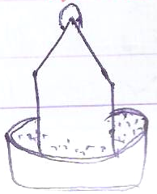
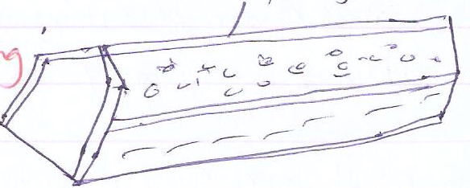
Feeding trough Conical drinking waterer or drinking trough
Spining handle

Classes of food needed in bird’s diet.
Proteins
- They build the body of a bird.
- They can be got from insects, fish, meat, beans.
Carbohydrates
- They provide energy to the birds.
- They are got from maize, millet, cassava, sweet potatoes, rice.
Vitamins
- They keep the body of a birds healthy.
- Vitamins can be got from green vegetables and fruits.
Fats and oils
- They also produce energy and heat in bird’s body.
- They are got from groundnuts, meat, peas, butter and margarine.

Mineral salts
- Birds need iron for blood formation.
- Calcium and phosphorus for strengthening bones and hardening eggs shells.
- Minerals can be got from vegetables, lime stone, common salt, and oyster shells.
Good feeding practices in poultry
- Keep the feeding trough and waterer clean.
- Don’t mix fresh feeds with stale ones.
- Measure, record and give correct amount of feeds per day.
- Give correct feeds to the right type of chicken.
- Serve birds with clean water for drinking regularly.
- Give birds feeds containing calcium to prevent laying soft shelled eggs.
- Mix small stones in mash for easy digestion of food in the gizzard.
Digestive system of a fowl.
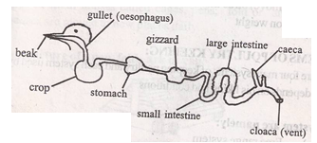

(Ileum)

Functions of each part.
Beak - It is used to pick food from the ground.
Oesophagus - It is a passage of food to the crop.
Crop - It stores, moistens and softens food before it goes to the stomach.
Stomach - It also stores food.
Gizzard - It is where food id crushed/broken down into small particles by the help of small stones called grits or palables.
The gizzard is adapted to its function because it has small stones called grits which crush food to small particles.
Ileum - It is where absorption of food takes place.
Colon - It is where absorption of water takes place.
Caeca - This is where undigested food/dropping are stored before being passed out.
Vent - It is where droppings and undigested food are passed out of the bird’s body.
-It also serves the purpose of laying eggs in hens.
Methods/systems of keeping poultry.
There are four systems used to rear poultry:
- Free range system
- Fold pen system
- Deep litter system
- Battery cage system.
Free range system
- This is a system where birds are left to move freely and look for their own food.
- It is mostly practiced in rural areas and it’s the commonest.
- It may require fencing where applicable.
Advantages of free range system
- It is cheap in terms of feeding since birds look for their own food.
- Birds eat a variety of food hence getting a balanced diet.
- Vices are reduced and controlled.
- It doesn’t require a lot of attention and labour since birds feed on their own.
Disadvantages of free range system.
- The system requires a large piece of land.
- Eggs can easily be lost and difficult to collect.
- Birds can be attacked and killed by wild animals and birds of prey.
- Birds can be stolen by thieves easily.
- Birds can easily pick up parasites and disease as they feed.
- Record keeping of birds is difficult,
- Birds can be poisoned easily.
Fold pen system
- This is a system where a few birds are kept in small houses called cages, pens, folds or arks.
- These pens are moves from place to place daily.
Diagram of a fold/pen cage
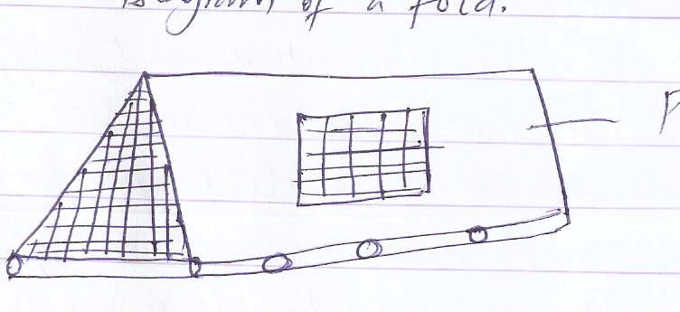
Pen

Advantages of fold pen system.
- Manure is easily spread on the farm.
- Birds don’t get lost easily since they are restricted to move.
- Sick birds can be indentified and culled easily.
- Birds get enough sunlight and vitamins easily.
- Birds are protected from predators and birds of prey.
Disadvantages of fold pen system.
- A lot of labour is needed to carry pens daily.
- It requires a large piece of land.
- Birds don’t get enough physical exercises.
- Folds can get spoilt easily due to constant movements.
- The system may not work in swampy areas and flood prone areas.
Deep litter system
- This is a system where many birds are kept inside a house.
- The floor of the house is covered by soft materials called litter.
- Litter is any soft material put on the floor of a deep litter house e.g, wood shavings saw dust, chopped dry grass, dried leaves, coffee husks and maize cobs.
- Litter helps to absorb moisture and droppings in the house/reduce dumpness in the house.
Items needed in a deep litter house
Laying nets - It s where birds lay their eggs.
- They should be dark inside to discourage egg eating.
Perches - It’s where birds play and rest from.
Feeding trough- It’s where mash is served to birds.
Litter - It absorbs moisture and dropping in the house.
Advantages of a deep litter system.
- Birds can not easily be attacked by predators.
- Very many birds can be kept in a small space.
- Eggs are collected easily.
- It requires a small piece of land.
- Birds can’t easily be poisoned, get lost or be stolen.
Disadvantages of deep litter system
- Diseases can spread quickly in case of an out break.
- Vices are very common among birds.
- Litter may be a fire hazard.
- Birds don’t get enough physical exercises.
- It is difficult to keep records of each bird.
Diagram of a deep litter house
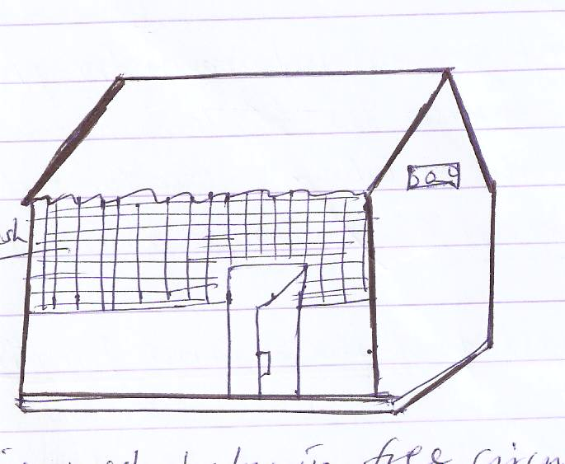
NB: The wire mesh helps in free circulation of air, provision of light and protects poultry from wild animals.
Battery cage system
- This is an intensive system where birds are kept in cages made of wires.
- Each cage may have 1 – 4 birds and the floor of the battery house is cemented to enable easy cleaning.
Advantages of a battery cage system.
- Birds can’t get lost or poisoned easily.
- Birds are protected from predators and birds of prey.
- Diseases and parasites can be controlled easily.
- Vices are controlled since each bird is kept in a separate cage.
- Eggs can easily be collected from the cages.
Disadvantages of battery cage system.
- It is every expensive system in terms of house construction and making cages.
- Birds don’t get enough room for physical exercise.
- Cages can bruise the birds.
- It requires a lot of labour to care for each individual bird.
- It needs a qualified person to manage it.
Poultry diseases and parasites
Causes of disease among poultry.
- Poor ventilation of the house.
- Over crowding of birds in small rooms.
- Poor feeding of birds or feeding birds on contaminated feeds.
- Poor sanitation in the poultry house/keeping birds in a dirty environment.
Common diseases of poultry.
- Coccidiosis - New castle disease
- Fowl pox - Pneumonia
- Black head - Colds
- Fowl typhoid - Aviain leucosis
- Gumboro
Note: Diseases which affect both poultry and rabbits are coccidiosis, pneumonia and colds.
Protozoan Diseases of Poultry.
- Coccidiosis
- It is caused by a protozoan germ called coccidia.
- It affects the liver, small intestines and large intestines.
Signs and symptoms of coccidiosis.
- Blood stained diarrhoea.
- Ruffled feathers.
- Loss of appetite and weight.
- Dullness and dropping of wings.
- Loss of body shape.
Prevention control and treatment of coccidiosis.
- Mix drugs called coccidiostats in the feeds.
- Cull and slaughter infected birds.
- Avoid over crowding of birds in one room.
- Keep birds in clean places.
- Avoid feeding birds on contaminated food and water.
- Black head.
- It is also caused by a protozoan germs.
- It kills a large number of birds if not treated early.
- Black head mainly attacks turkeys.
Signs and symptoms of black head.
- Yellowish coloured diarrhea.
- Dark purple head.
- Swollen liver and legs.
Prevention and control of black head.
- Avoid over crowding of birds.
- Separate turkeys from other fowls.
NB: A sign of a disease can be seen with our eyes while a symptom is what the patient feels.
Viral Diseases of Poultry

Fowl Pox
- It is caused by a virus.
- It is spread by biting insects and through wounds caused by feather and skin pecking.
Signs and symptoms of fowl pox.
- Difficulty in breathing.
- Tinny wounds on the head, comb, wattle and wings.
- The eyes get sleepy and stuck.
- Loss of appetite and body weakness.
- Moulting of feather.
Prevention and control of fowl pox.
- Vaccinate the birds after every 6 months with anti-fowl pox vaccine.
- Cull and slaughter infected birds.
- Clean and disinfect the poultry house.
2. Gumboro
It is also caused by a virus.
Signs and symptoms of Gumboro.
- Dropping of wings
- Diarrhea
- Rough feather
- Loss of weight and appetite.
- Pecking of beaks among birds.
Ways of preventing Gumboro.
- Separate healthy birds from the unhealthy ones.
- Vaccinate birds with Gumboro vaccine at 2-4 weeks.
- Burn or burry dead birds.
- New Castle disease.
- It is caused by a virus in a myxo-virus group.
- The virus may be spread from an adult to a young one through the egg.
- It mainly affects the breathing system.
Signs and symptoms of Newcastle.
- Sneezing and coughing with difficult breathing.
- Sudden drop in egg production.
- Poor egg shell formation.
- Staggering droppings of wings and bending of the neck.
- Loss of appetite.
- Very many birds may die if not treated early.
Prevention and control of New Castle disease.
- Vaccinate birds after every six weeks.
- Maintain proper hygiene of the poultry house.
- Kill the whole flock in case of an out break.
- Clean and disinfect the whole house.
Bacterial Diseases of Poultry
1. Pneumonia
- It is caused by bacteria.
- It spreads through air from an infected bird to another after sneezing/coughing.
- The disease mainly affects the lungs.
Signs and symptoms of Pneumonia.
- Difficult breathing.
- Coughing
- Loss of appetite and weight.
- A mucus discharge comes out from the nostril.
Prevention and control of Pneumonia.
- Keep the poultry house clean and dry.
- Isolate/ separate healthy birds from unhealthy ones.
- Keep the poultry house well ventilated.

2. Fowl Typhoid.
- It is caused by bacteria called salmonella typhi.
- It spreads through drinking contaminated water and eating contaminated food.
Signs and symptoms of fowl typhoid.
- Yellowish –green diarrhea
- Sleepy eyes
- Dullness and dropping of wings.
- Rough feather
- Loss of appetite.
Prevention and control of fowl typhoid.
- Keep the poultry house clean, dry and well ventilated.
- Separate infected birds from healthy ones.
- Vaccinate birds regularly.
- Burn or burry dead birds.
Avian Leucosis
- It is a viral disease which causes cancer in chickens.
- It is an infected disease of poultry which causes sudden death of birds.
Signs and symptoms of Avian Leucosis
- Paralysis of legs and wings.
- Cancer tumours may be detected in bird’s body organs.
- Sudden death of birds.
- Drop in egg production, enlargement of abdomen and liver.
- Loss of weight.
Ways of preventing and controlling Avian Leucosis.
- Keep birds of resistant breeds.
- Disinfect the poultry house and keep it clean.
- Keep the feeding trough and waterer clean.
- Get chicks from a single source and don’t keep birds of different ages together.
General control measures of preventing all poultry diseases.
- Isolate (separate) the sick birds from healthy ones.
- Burn or bury dead bird.
- Keep the poultry house clean and dry.
- Disinfect the poultry house regularly and have good ventilation.
- Vaccinate the birds regularly against Newcastle, fowl pox and fowl typhoid.
- Mix preventive drugs in the mash e.g. coccidiostat.
- Always give birds clean water and fresh feeds.
Poultry parasites
Parasites are living organisms which depend on others for food without killing them.
Types of parasites
- Endo parasites or internal parasites
- Ecto parasites or external parasites.
External/ecto parasites
These are parasites which live/attack outside the body of a living organism.
Lice, mites, fleas.
Diagram of ecto parasites
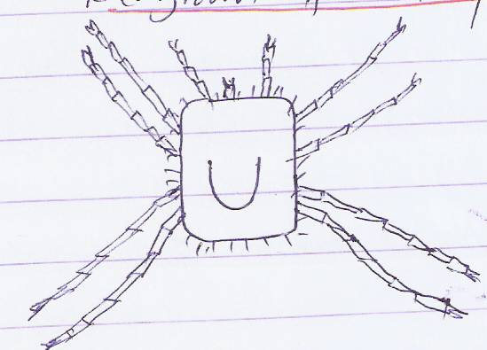
Chicken mite
Chicken louse

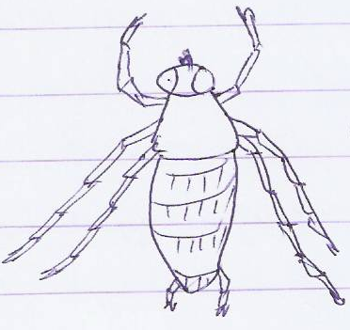

Ways of controlling ecto parasites among birds.
- Spray the birds regularly with pesticides to kill them.
- Dust the birds with powdered chemicals like sodium fluoride powder and pyrethrum powder.
- Swab the body of birds with paraffin to kill ecto parasites.
- Apply Vaseline on the spots with fleas and mites.
Note: Dusting is the spraying of powdered chemicals on the birds’ body to kill ecto parasites.
Endo/internal parasites
- These are parasites which live and attack inside the body of an organism.
- They attack organs of the digestive system e.g, liver, small intestines and large intestines.
Examples of endo parasites in birds.
- Tape worm
- Round worms
- Liver flukes
- Hook worms.
Dangers/effects of endo parasites to birds.
- They lead to drop in egg production.
- They suck blood of birds and cause anaemia.
- Birds loose weight and become weak.
- They can lead to death of birds if not treated.
Control and treatment of endo parasites.
- Feed birds on clean feeds and water.
- Deworm the birds regularly.
Deworming
Deworming is the giving of medicine to an organism to kill internal worms/parasites.
Types of deworming
- Drenching – This is the giving of liquid medicines to an organism to kill worms/endo parasites.
- Dosing - This is the giving of solid medicines to an organism to kill worms/endo parasites.
General Control Measures of Poultry Parasites
- Deep the feet of birds in Kerosene to control ecto parasites.
- Dust the birds regularly and the laying nets.
- Keep the poultry house clean.
- Spray the poultry house to kill parasites.
- Swab the body of birds with paraffin to kill lice, mites and fleas.
- Deworm the birds regularly to kill endo parasites.

POULTRY VICES
Poultry vices/fowl vices are bad habits among poultry.
Causes of fowl vices
- Lack of enough food (poor feeding of birds)
- Over crowding of birds in one room.
- Boredom among birds.
- Lack of proteins in the bird’s diet.
- Too much lighting in the poultry house.
Examples of fowl vices
- Egg eating
- Cannibalism
- Toe pecking
- Feather/skin pecking.
Cannibalism
This is a vice where birds eat flesh of fellow birds.
The main cause of cannibalism is prolapse.
Prolapse is when birds peck the oviduct of a layer which has comes out of the vent.
Prolapse is a condition when the oviduct of a layer comes out of the vent.
Other causes of cannibalism
- Lack of enough food/poor feeding of birds.
- Boredom of birds or lack of exercises among birds.
- Lack of proteins in the bird’s diet.
- Too much light in the poultry house.
Ways of controlling cannibalism among birds.
- Hang bundles of green vegetables in the house to keep birds busy.
- Give birds enough food.
- Feed birds on feeds containing proteins.
- Isolate the wounded and pecked birds.
- Reduce the amount of light in the house.
Signs of cannibalism among poultry.
- Blood stains on the flour
- Bleeding of birds in the house.
- Blood stains on the beaks of birds.
- Dead birds in the house and pecking of dead birds.
Debeaking
Debeaking is the shortening/cutting short of the birds’ upper beak.
It is done to reduce sharpness of the beak using a hot knife.
NB: The main reason for debeaking is to control all fowl vices.
Egg eating
This is a habit where birds eat their eggs especially the layers.
Causes of egg eating
- Poor feeding of birds.
- Laying of soft shelled eggs.
- Too much light in the laying corners/nests.
- Lack of calcium in birds’ diet.
Signs of egg eating
- Yellow stains on the beaks.
- Broken eggs and shells in the room.
- Yellow stains on the floor.
NB: Some hens lay soft shelled eggs because they lack enough calcium and phosphorus in the diet.
Ways of preventing egg eating.
- Give birds enough food rich in proteins and mineral salts.
- Remove all broken shells from the house.
- Avoid overcrowding of birds.
- Debeak the egg eaters.
- Keep the laying nests in dark places.
- Collect the eggs from the poultry house regularly.
Feather pecking/skin pecking
- This is an act in which a bird plucks off feather from other birds.
- It is common during moulting.
- Moulting in birds is the process of shedding off feather from the bird’s body.
Causes of feather/skin pecking
- Lack of exercise and boredom.
- Lack of enough feeds/poor feeding.
Ways of preventing feather/skin pecking.
- Hang bundles of green vegetables in the poultry house.
- Provide enough feeds in the house.
NB: Bundles of green vegetables are hung in the house to keep the birds busy and also provide vitamins to birds.
Toe pecking
This is common in chicks, where some chicks peck the toes of other until blood comes out because scales on their feet are not strong enough.
Signs off toe pecking
- Bleeding of feet
Ways of preventing toe pecking.
- Provide enough light in the house.
- Provide enough light in the house.
- Keep birds busy by providing bundles of green vegetables.
EGG FORMATION
- The ovary of a hen contains thousands of ova/ovum.
- The ova are the female productive cells of an animal.
- These ova develop at a regular internal into the yolk of an egg.
- When fully developed, the yolk passes down the oviduct.
- In the oviduct the ovum is fertilized by a sperm of a cock.
- The sperm is a male reproductive cell of an animal.
- After fertilization, the ovum moves to the magnum where the albumen is added to it and later to the uterus where the shell is added to the egg.
The whole process of egg formation takes 24 -26 hours. This means a hen can only lay one egg in a day.
Note: Unless the ova are fertilized before the albumen and are added to the egg, it will be laid when it’s infertile.
FERTILIZATION
- Fertilization is the union/fusion of the male and female nuclei to form a zygote.
- Fertilization occurs in the oviduct.
- A hen can lay eggs whether fertilized or not.
- A fertilized egg takes 21 days/3 weeks to hatch into a chick.
- Birds have internal fertilization.
Diagram of the reproductive system of a hen
Funnel

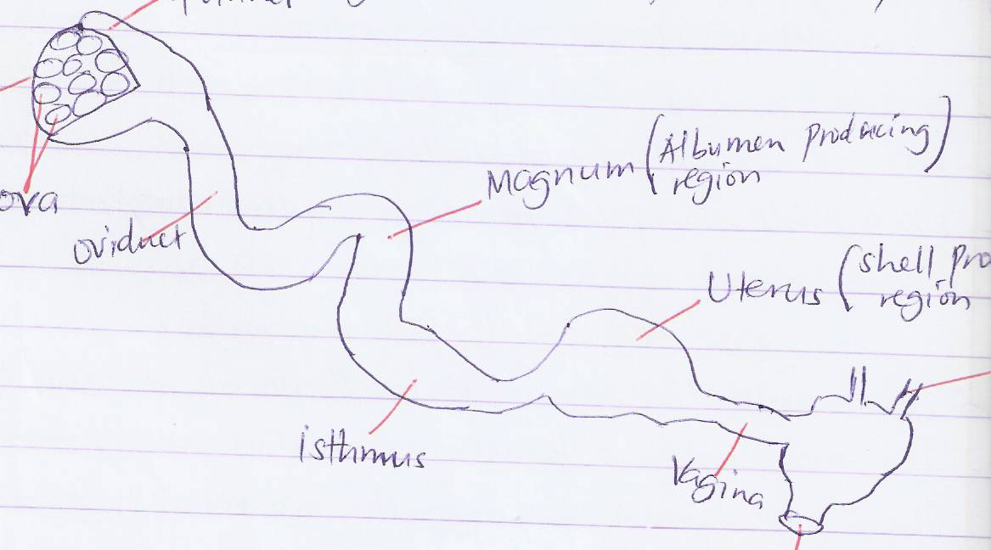
ovary
Magnum(Albumen producing region)
Oviduct
ova
Isthmus
Uterus (Shell producing region)

Caeca

Vagina
Vent (cloaca)
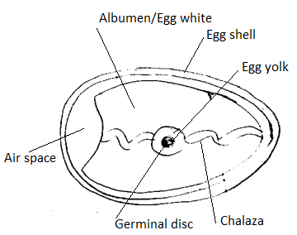
Internal structure of an egg.

Germinal disc
Chalaza
Functions of each part of an egg.
Egg shell
- It protects the inside/inner parts of the egg.
- The egg shell is porous or permeable because it has pores/tiny holes which allow gaseous exchange between the egg and surroundings.
Air space
- It stores and keeps fresh air for the embryo.
Chalaza
- It holds the yolk and embryo in one position.
- The Chalaza also supplies fresh air to the embryo from the air space.
Egg yolk - It is a source of fats and proteins to the embryo.
Egg white (Albumen) - It’s a source of water and proteins for the embryo.
Germinal disc – Develops into a chick after fertilization or develops into the embryo.
NB: An embryo is the living part of a fertilized egg or the part which grows into a chick in a fertilized egg.
INCUBATION
- It is the development of an embryo into a chick.
- This is the process by which eggs are given necessary/favourable conditions to hatch into chicks.
- Process by which fertile eggs develop into chicks.
Conditions necessary for eggs to hatch.
- Warmth
- Oxygen
- Constant changing of eggs.
- The eggs should be fertilized.
Incubation period
This is the time taken for an egg to hatch into a chick.
Incubation Periods of different birds.
Hen - 21 days
Turkey - 28 days
Pigeon/dove - 14/16 days
Duck - 28 days
Geese - 30 days

Qualities of eggs to be incubated
- should be medium size with oval shape
- should be fertilized
- should not have cracked shell
- should be clean, smooth with thick shell
- The yolk should be centrally placed
- should not have abnormalities e.g double yolk, blood strains

Factors that may cause eggs not to hatch
- unfertilized eggs
- cracked or broken eggs
- eggs which have overstayed
- over heating eggs during incubation
- low heat during incubation
Types of Incubation
Natural incubation and artificial incubation.
Natural incubation
- This is where a mother hen sits on her eggs and hatches into chicks.
- The hen which sits on its eggs to hatch into chicks is called broody hen.
- The broody hen sits on the eggs for 21days. It occasionally comes off to feed and get exercises.
Factors (things done) for natural incubation to be successful.
- A broody hen should have a good nest.
- It should be protected from vermins (pests) like; rats, snakes, cats and dogs.
- The place should be sheltered from strong wind, rain and sunshine.
- The eggs should be fertilized.
- The broody hen should be given water and food.
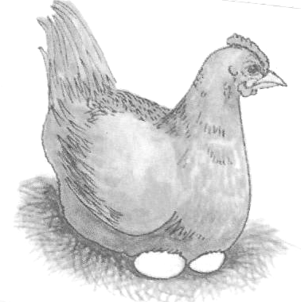
Diagram of a broody hen

Nest

Advantages of natural incubation
- It’s cheap to manage by a farmer.
- There is little attention given to the broody hen.
- Chicks get extra care from their mother.
- The farmer is not over worked.
- There are less chances of breaking eggs
Disadvantages of natural incubation
- Few chicks can be hatched at a time.
- The broody hen may easily be attacked and killed by vermins.
- The hen can neglect the eggs when disturbed.
- It can’t serve commercial purposes.
Artificial incubation
- This is where a machine called an incubator is used to hatch eggs into chicks.
- An incubator is a machine used to hatch eggs into chicks.
- It provides all the necessary conditions for the eggs to hatch into chicks.
- Incubators can use either paraffin or electricity to provide warmth to the eggs.
NB: Before putting eggs in an incubator, they have to be checked using light, this is called candling.
Candling is the checking for disorders in eggs using a candle.
A candle has light which can be used to view inside the egg.
Disorders which can be found in eggs during candling.
- Blood stains
- Two yolks/double yolks.
- Cracked egg shells
- Unfertilized eggs.
Diagram of an electric incubator.
Vent
Cover
Thermometer
Eggs
Air
Water
Heater
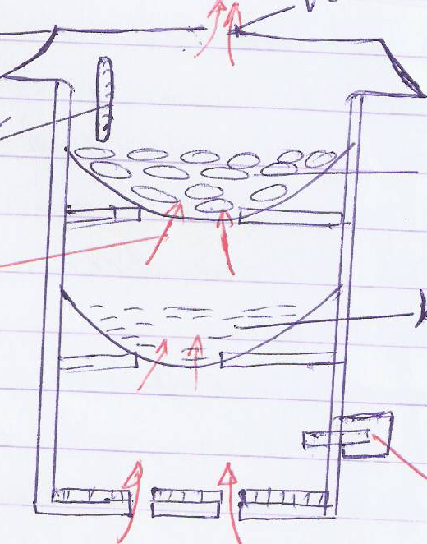

Importance of the following in an incubator.
- Thermometer - It measures temperature in an incubator.
- Water - It reduces the temperature inside incase of too much heat and also provides moistures.
- Heater - It provides the necessary warmth to eggs.
Advantages of artificial incubation
- Very many eggs can be hatched at ago.
- It can be used to hatch chicks for commercial purposes.
- Eggs can’t be attacked by vermins.
Disadvantages of artificial incubation.
- It is an expensive method to manage.
- It requires a lot of labour to provide special care.
- Eggs may fail to hatch incase of power shortages
- The farmer is over worked due to constant supervision and changing of eggs.
- The method requires trained person to manage it.
BROODING
This is the giving of care to young chicks.
They are given care from the time of hatching (one day old) up to 8 weeks.
Types of brooding
- Natural brooding
- Artificial brooding.
Natural brooding
- This is when a mother hen takes care of her chicks after hatching them.
- It’s common in local breeds.
Advantages of natural brooding
- The hen provides security to her chicks.
- A hen provides shelter for her chicks through covering them under her wings and feathers in cold weather.
- It looks and provides food to the chicks.
- Natural brooding is cheap to a farmer.
- Toe pecking among chicks is not common.
Disadvantages of natural brooding
- Chicks can be eaten by wild animals and birds of prey.
- Chicks may die if their mother is stolen or killed.
- A few chicks can be raised.
- It can not be used for commercial purpose.
- Some chicks can get lost easily from their mother.
Artificial brooding
- This is where chicks are kept and taken care of in a special structure called brooder.
- A brooder is a special structure where chicks below 8 weeks are taken care of.
- Warmth, food and water are provided to the chicks in the brooder.
Types of brooder
- Kerosene/paraffin brooder.
- Infra red lamp brooder.
- Here, paraffin lamps are used to provide warmth to the chicks and some times charcoal stoves are used.
- It needs careful handling to avoid too much vapour and soot in the brooder and also prevent chicks from getting burnt.
Infra red lamp brooder
- Here electricity is the source of heat and light.
- The infra red lamp is hung from the ceiling and adjusted as chicks grow.
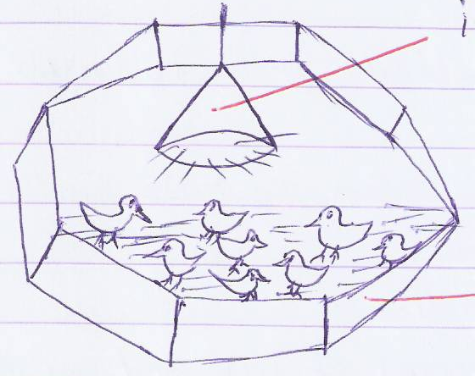
Infra red lamp
Wooden structure of timber

Advantages of artificial brooding
- Many chicks can be raised at ago.
- Chicks are protected from wild animals and prey birds.
- It is easier to feed chicks in one place.
- It can be used to raise chicks for commercial purposes.
- Chicks can’t get lost easily.
Disadvantages of artificial brooding
- Toe pecking among chicks is very high.
- It is expensive to buy feeds for the chicks.
- All chicks many die if there isn’t enough warmth in the brooder.
- It requires a high labour to care for the chicks.
Proper management practices in poultry.
- Vaccinate birds against diseases regularly.
- Keep the poultry house clean, dry and well ventilated.
- Debeak the birds to control vices.
- Collect eggs regularly against worms.
- Cull the sick and un productive birds.
- Feed birds well on clean water and fresh feeds.
- Dust the laying nests or boxes with pesticides to kill mites, lice and fleas.
- Mix grits in the bird’s mash to enable easy digestion in the gizzard.
- Hang bundles of green vegetables in the poultry house to keep birds busy.
- Keep farm records.
NB: Culling is the removal of sick and un productive birds from the flock.
- It’s done to control the spread of diseases and wastage feeds to un productive birds.
FARM RECORDS
These are written documents kept on a farm showing all farm activities.
Examples of records kept on a poultry farm.
a) Production records - It states the number of eggs laid daily.
b) Flock records - It shows the number of birds on the farm.
c) Health records _ It indicates the number of healthy and sick birds.
d) Feeding records _ It shows the amount of feeds given to poultry daily.
e) Sales and expense record - They show the amount of money earned and spent.
Importance of keeping farm records.
- They help a farmer to plan and budget for the farm.
- They help farmers to know their profits and loses.
- They enable farmers know the income earned and expenditures of a farm.
- Records enable a farmer to know the total number of birds on his farm.
- Records enable a farmer to determine the amount of feeds used daily.
- They help farmers to make decisions on the farm.
BEE KEEPING (APICULTURE)
- Bees are social insects which live in large and organized groups called colonies.
- These colonies live in habitats called bee hives.
Apiculture - Is the rearing of bees.

Social insects
- Social insects are insects which live and work together in organized groups called colonies.
Examples of social insects
- Bees - White ants
- Termites - Wasps
- Black ants - Red ants
Solitary insects
These are insects which don’t live and work together.
Examples of solitary insects.
- Butter flies - Mosquitoes
- House flies - Locusts
- Beetles - Moth
- Cockroaches - Praying mantis
- Dragon flies - Crickets
- Black flies - Grass hoppers
Characteristics of insects.
- They have three main body parts.
- They have three pairs of legs/6 legs.
- Insects breathe through spiracles.
- They have exo-skeleton.
- They have two compound eyes.
Types of bees
- Queen bee
- Drone bee
- Worker bee
The queen and workers are female bees while the drones are male bees.
THE QUEEN BEE
- It is the master or leader bee in the hive.
- Its main function is to lay fertilized eggs.
- The queen is the largest bee in the colony.
- It has a longer abdomen and short wings compared to the rest of the body.
- It has an ovipositor on the abdomen which is used to lay eggs.
- It can lay about 1000 – 2000 eggs per day.
- The queen bee is fed on special food prepared by the nurse bees called Royal jelly.
- The queen mates once in her life time and stores the sperms in a sack called sperm sack in her abdomen.
- The queen bee lays fertilized eggs in special structure called cells made by worker bees in the brood chamber.
- The queen bee lives for about 4- 5 years.
- When the queen dies or become old, the nurse bees select some larvae and feed them on royal jelly for the new queen to develop.

Diagram
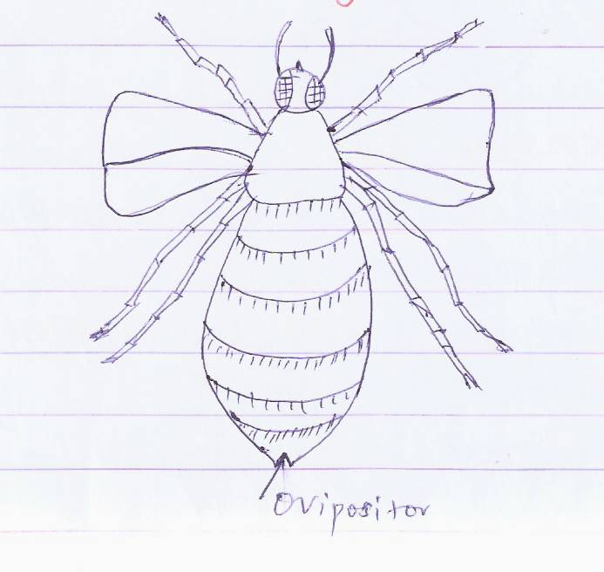
Ovipositor

DRONE BEE
- These are the male bees in the hive.
- The main function of a drone bee is to fertilize the eggs of the queen bee.
- They are larger than the workers bees.
- They have a brood, blunt abdomen with no stings.
- They make a buzzing sound when flying.
- Drones are not often found in the hives since they are killed after fertilizing the eggs of the queen by the worker bees.
- Drones are fed by worker bees because they don’t collect any food. In case of food shortage, they can be chased away by the workers.
NB: Mating of a drone and queen bee takes place in a marriage flight and a drone bee mates only once in its life time and thereafter killed by the workers.
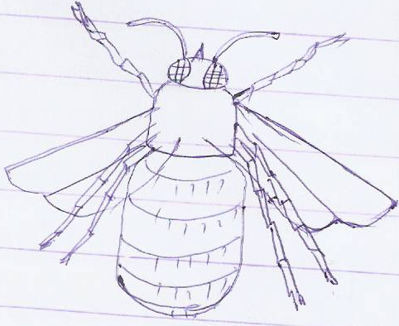
Diagram of a drone.

WORKER BEES
- They are female sterile bees because they do not produce or lay eggs.
- They are the smallest in size but very many in number (in thousands)
- They are the most hardworking bees in the hive and they are commonly seen on flowers.
- They have a sting at the end of their abdomen used for protection/defense against enemies.
- Their hind legs have a pollen basket and long hairs where pollen is carried.
- Worker bees die after stinging their enemies because the sting gets stuck inside the victim’s body and danger their abdomen.
- Worker bees live between 6 weeks – 6 months.
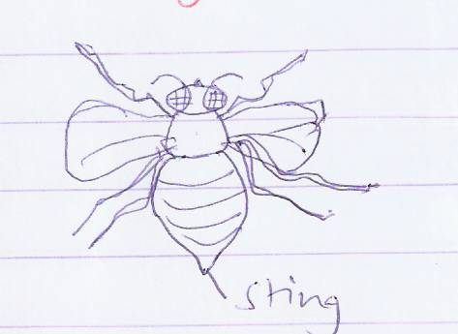Diagram
Sting

Duties of worker bees in a hive.
- Worker bees feed the queen and grub.
- They clean the hive by removing bees from the cells.
- They guard/protect the hive from enemies.
- They control temperature in the hive by flapping their wings.
- Worker bees build combs used for storing honey and making cells. The combs are built from a substance called bee wax made in their bodies.
- The wax comes from the honey which they eat. Combs are made in hexagon shapes called cells.

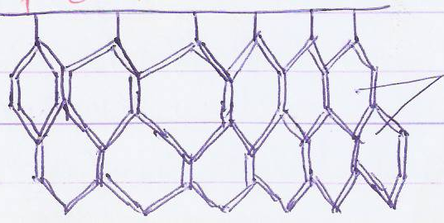
Diagram of combs

Cells

- Worker bees also collect water nectar, pollens and propolis.
- Nectar is used to make honey which they store as their food.
- They use the proboscis to suck nectar from the nectar glands found at the petal base of most flowers.
- Pollen is carried in pollen baskets found on their legs and it’s used as food for the grub.
NB: Pollen is a good source of proteins and is a source of carbohydrates.
- Worker bees also collect propolis from different trees.
Propolis is a sticky substance collected from different trees.
Uses of propolis in a hive.
- Propolis is used to repair cracks in the hive.
- It is used to smoothen inside the hive.
- Propolis is used as a water proof for the brood cells.
SWARMING IN BEES
A swarm is a large group of bees. It may be over 20,000 bees.
Swarming is the movement of bees from one place to another in search of a new hive (looking for a new hive)
Reasons why bees swarm.
- Overcrowding of bees in the hive.
- When a new queen bee is produced/hatched.
- Shortage of water and food within the area of a hive.
- When attacked by their enemies.
- Dumpness and bad smell of the hive.
- Over heating of the hive through direct sunshine.
- Poor ventilation of the bee hive.
- Damaging of the grub, combs and hive due to strong wind and bee keepers.
- Too much noise near the hive.
- Bees can swarm if the hive leaks after raining.
- They swarm when the queen bee is infertile.
Life history of a honey bee.
- Bees have a complete metamorphosis.
- The queen bee lays and egg in a prepared cell in the brood chamber.
- The egg hatches into larva which is called grub or brood.
- The larva is fed by the worker bees and sealed inside the cell where it develops into pupa and later to adult.
Metamorphosis
- These are the stages of development in the life cycle of an organism e.g, insects and amphibians.
Types of metamorphosis in insects
a) Complete metamorphosis – Is the types of metamorphosis where an insect undergoes 4 stages of development.
b) Incomplete metamorphosis - Is the type of metamorphosis where an insect undergoes 3 stages of development e.g, cockroaches, locusts, grasshoppers and praying mantis.
NB: The three stages are; Eggs, Nymph, and Adult.

Diagram showing the life cycle of a bee.
PUPA
EGG
LARVA
ADULTS
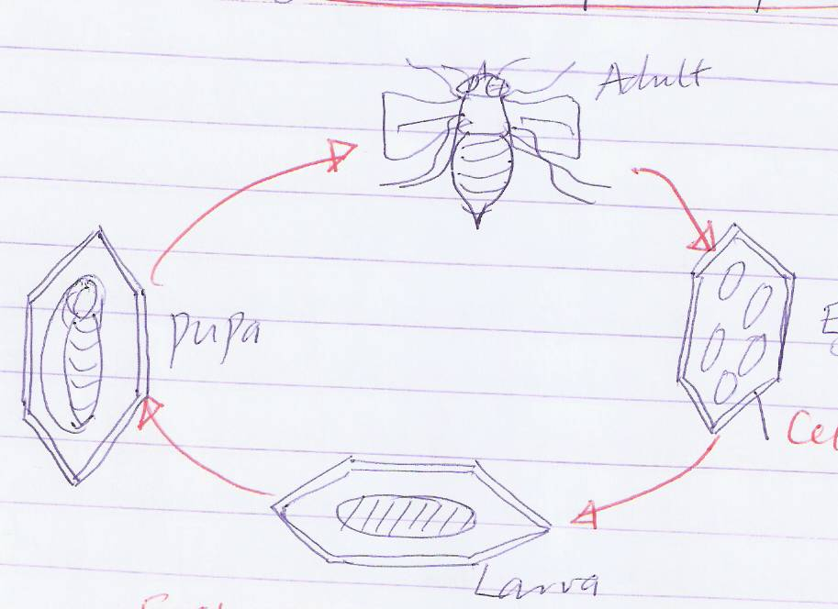

External parts of an adult honey bee.
Thorax
Wing
Abdomen
Sting
Spiracles
legs
Antenna
Head
Compound eye
Proboscis
Pollen basket
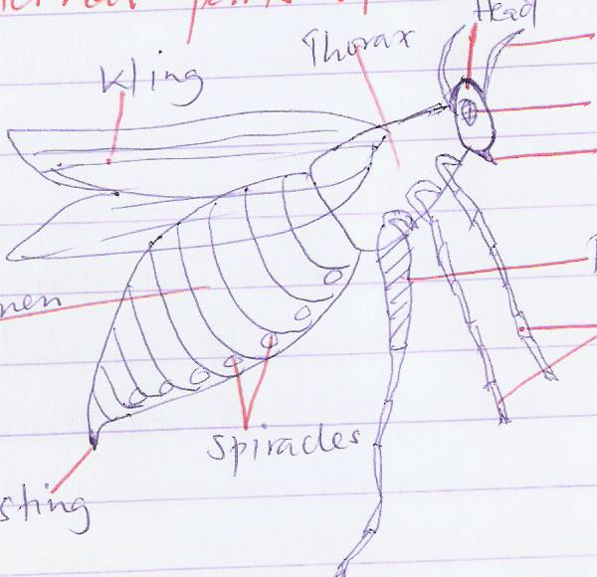

Functions of some parts
Antenna - It’s a sense organ for feeling, smell and detecting danger.
Pollen baskets - It is used for carrying pollen from flowers.
Spiracles - They are used for breathing.
Proboscis - For suckling nectar from flowers.
Wings - For flying.
Haltere - For balancing in air during flight.
Sting - For protecting against enemies.

Bee hives
Naturally bees live in holes underground, hallows of big trees and holes under rocks.
A bee hive is a home /habitat of a bee.
Types of bee hives
- Traditional bee hives
- Modern bee hives.
Traditional bee hives.
These are bee hives made from local materials like tins, boxes, logs and straws.
Examples of traditional bee hives.
- Dug out log hive
- Kigezi hive
- Tin hive
- Box hive.
Diagram of each
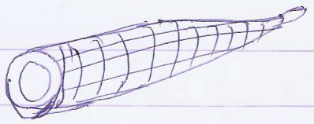
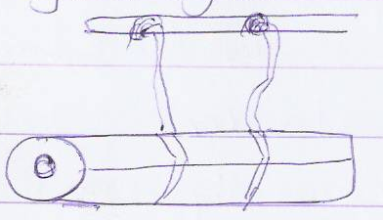
a) Dug out log hive b) Kigezi hive

Rope
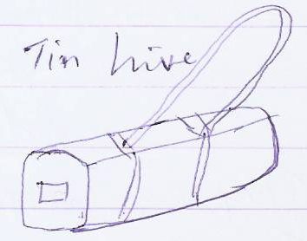
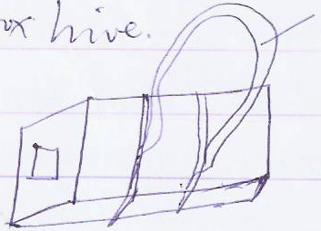
- Box hive d) Tin hive

Modern bee hives
These are hives made using timber, iron sheets, nails and divided into sections e.g, the top bar hive.
Internal structure of a top bar hive.
Brood chamber
Queen excluder
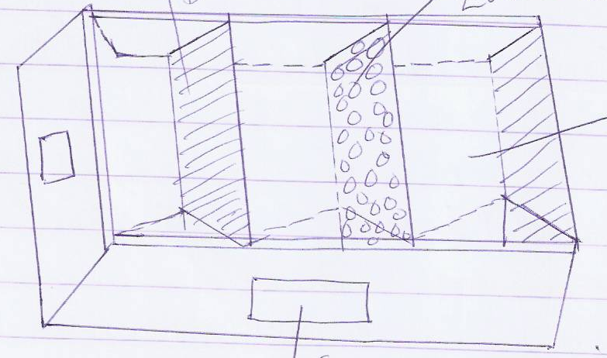
Honey chamber

Entrance
Functions of each chamber in a modern hive.
Brood chamber - It is where the queen bee lays its eggs.
Honey chamber - This is where honey and pollen are stored.
Queen excluder
- It prevents the queen bee from crossing to the honey chamber to mix eggs with honey.
- It also separates the honey chamber from the brood chamber.
- The queen excluder is made using a small sieve or wire mesh which doesn’t allow the queen bee to pass through but allows workers to pass through.
Advantages of traditional bee hives.
- They are cheap and easy to make.
- The colony is not constantly disturbed by the bee keeper.
- They are not easily attacked by ants and other enemies since they are hung high up in trees.
Disadvantages of traditional hives.
- The colony can not be inspected by the farmers.
- The hive can be damaged in the process of harvesting honey.
- It is difficult to replace a queen and prevent swarming.
Advantages of a modern were hive.
- Bees build their combs on each bar.
- The bars can be removed individually for inspection.
- The honey harvested is clean and doesn’t contain the brood and combs.
- Combs which are ready can be removed without destroying others which are not ready.
SITING A HIVE
This is the selecting of a good/suitable place in which to put a bee hive.
Factors to consider when looking for a good place to put a bee hive.
- The place should be far from people’s homes roods and animals’ farm.
- The place should be near flowering plants.
- The place should be free from noise.
- It should be near a water source.
- Hives should be put in a shade to protect them from strong wind, sunshine and rain.
- The grass around the hive should be kept short.
- Hives should be hung near the ground for easy harvesting and inspection.
An apiary
An apiary is a place where many bee hives are set up.

Stocking a hive
This is the putting of bees in an empty hive or encouraging bees to enter an empty hive.
Ways of stocking empty hives.
a) Place a hive in a permanent area and smear inside with bee wax or honey and wait for bees to come on their own.
- By using a catcher box.
- This is where a small hive or box is placed on top of a bigger hive for sometime.
- After the bees have entered in it, they are later transferred to the main hive.
- By using a swarm catching net.
- The net is used to catch a swarm of bees hanging on a tree branch on a cool day.
- The swarm is then transferred to the main hive.
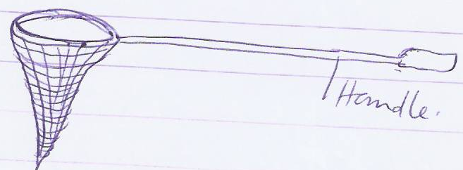
Diagram of a swarm catching net

Handle

Harvesting of honey
- Honey is harvested in the evening when it’s cool and all bees have settled inside.
- A bee keeper has to protect himself from bee strings when harvesting honey, inspecting the hive and transferring bees from one place to another.
Equipment used by a bee keeper when handling bees.
Gumboots - They protect the feet from stings and sharp objects.
Bee veil – It protects the face and heat from bee stings.
Overall – It protects the rest of the body from the stings.
Knife - It is used for cutting honey combs.
Bucket - It’s where harvested honey combs are carried from.
Gloves - They protect the hands from bee stings.
Smoker - It produces puffs of smoke which tames and calms the bees to make them docile.
Materials which can be used in a smoker.
- Dry grass
- Wood shavings
- Old sacks
- Dry leaves

Diagram of a person ready to harvest honey.
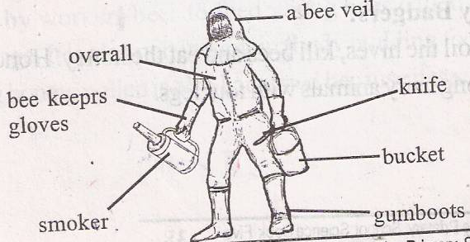

Extraction of honey
This is the removal of honey from honey combs.
It should be done in a closed place to prevent attacks from bees.
Methods used to extract honey
- Pressing honey method
- Floating the wax method
- Centrifuging methods.
Pressing honey method
Here, honey, combs are broken into small pieces and tied in a clean cloth and squeezed to allow the honey to come out.
Floating the wax method
- In this method, combs are broken into small pieces and heated.
- The wax and honey melts.
- Wax floats on top of honey and it is then removed.
- Honey is placed in clean containers like bottles and jerrycans for storage and the wax is taken to processing companies to make different items.
Centrifuging method
- In this method, a machine called a centrifugal honey extractor is used to remove honey from the combs.
- The machine turns the combs at every high speed to enable honey to come out.
- Honey settles at the bottom of a machine and wax floats on top.
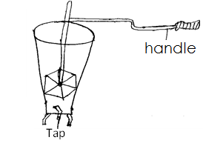

NB: Before storing honey in containers, it should be warmed or boiled to kill germs and prevent contamination.
Feeding bees
Naturally, bees get their food from flowers i.e nectar and pollen which they use to make honey.
However, they can be fed due to the following condition:
- When they are new in a hive.
- During drought conditions when flowers are scarce.
- They can be fed to encourage multiplication.
What are bees fed on?
- They are fed on sugar mixed with water to form a syrup, cassava flour, juice from banana.
- The syrup is put in a container about 10 metres away from the hive.
- They are also given clean water in a container at a similar distance.

ENEMIES OF BEES
- Wax moths
- Honey badgers
- Birds
- Hive beetles
- Hawk moth
- Safari ants, pirate ants and wood ants.
The above organisms attack bees to eat the honey which is stored in the combs.
Ways of preventing ants from attacking bees.
- Hang hives between poles or branches.
- Put grease or oil on wires or poles to prevent ants from reaching the hive.
Products got from bees
- Honey
- Bee wax
- Pollen
- Propolis
Honey – It contains carbohydrates so it’s an energy giving food.
Uses of honey
- It is used as a medicine for cough.
- Honey is used to sweeten tea.
- Honey can be applied on bread.
- Honey can be sold to get money.
- Honey is used in industries to make sweets.
- Chewing gums, biscuits, cakes, ice cream and medicine.
Bee wax – is got from combs after extracting honey.

Products got from bee wax.
- Candle wax
- Shoe polish
- Floor polish
- Cosmetics like Vaseline, lip sticks
- Wood varnish

Importance of bees to bee keepers/people.
- They provide honey which is eaten and sold to get money.
- They also provide bee wax used to make different items.
NB: The importance of bees to crop farmers/environment is that they help to pollinate flowers of plants.

TOPIC II- MEASUREMENTS
Measuring - is the process of finding out how long short, big small, heavy, or light an object is.
Length
Length is the distance between two points.
The distance between two points is a line.
The standard or basic unit for measuring length is metre (m)
Length can also be measured using the following units:
- Millimeter (mm) - Centimeter (cm)
- Decimeter (dm) - Metre (m)
- Decameter (Dm) - Hectometer (Hm)
- Kilometer (km)
NB: 1 metre = 100 cm
I metre = 1000mm
1 km = 1000m
1km = 1,000,000mm
The smallest unit for measuring length is millimeter and the biggest is kilometer.
When converting from small units to bigger units, we divide e.g 10000mm to metres.
10000 mm to metres
10000 mm
1000
= 10 metres

When converting from bigger units to small ones, we multiply e.g convert 10km to millimeters.
10km to millimeters
1 km = 1000,000mm
10km = 1,000,000 x 10
= 10,000,000mm

Substances used to measure length of objects
- Rulers - Tape measure
- Hand span - Strings
- Strides - Ropes
- Arm spans
Area
- Area is the total space occupied by a figure
- Area is measured in square units.
Finding area by counting square units
1 | 2 | 3 | 4 | 5  Area = 3 x 5 = 15 sq. Units
2
3

Area of a figure can also be found when we know the length and width of a figure.
5m
5m

10m
Area = LxW Area = side x side
= 10m x 5m = 5m x 5m
= 50m² or sq.metres = 25m²
Volume
- Amount of space in an object.
- Volume is the amount of space occupied by an object.
- Volume is measured in units called cubic units cubic centimeters (cm³ or c.c),cubic metres (m² or c.c)
- The volume of liquids which is called capacity is measured in litres.
- Capacity is the amount of space occupied by a fluid/liquid.
- Capacity is measured in litres.

Finding volume of objects.
Types of objects.
- Regular objects
- Irregular objects.
Regular objects
These are objects which have a well defined shape.
Examples of regular shaped objects
Cubes, cuboid, chalk box, bricks, block, tins, cylinders, boxes, books.
Irregular objects
These are objects which don’t have a specific or well defined shape.
Examples of irregular objects
Stones, needles, keys, padlocks, broken eggs shells, potatoes, cassava, mangoes.
Finding the volume of regular objects
It can be found if you know the length, width and height.
a) Finding the volume of a cuboid/rectangular prism.
V = lxwxh
3m
6m
2m
= (6cmx2cm)x3cm
= 12cm2 x 3cm
= 36cm3
b) Finding the volume of a cube.
V = (5x5x5) =5³
3cm

= 3 x 3 x 3
= 27 cm³
Find the volume of he figures below.
5cm
1cm
6cm
3m
5m
4m
i)

3cm

iii)

- A rectangular block has a length of 5m, a width of 3m and a height 7m. Find its volume.
Finding volume of irregular objects.
- The volume of an irregular object is measured using displacement method.
- When an object is put in water, it pushes out some water from the container, this is called displaced water.
- Its called displacement method because the irregular object displaces the amount of water which is equal to its volume.
There are two containers used to measure volume using displacement method.
- Measuring cylinder
- Over flow can/Eureka can.
Using a measuring cylinder.
Step 1 - Pour water into a measuring cylinder and record its volume.
Step 2- Get an irregular object, tie a string around it and lower it into the measuring cylinder.
- Record the second volume.
2nd level
1st level

30cc
25cc
20cc
15cc
10cc
5cc
String

30cc
25cc
20cc
15cc
10cc
5cc
Step 1
Step 2
Measuring cylinder

The volume of the object will be got by subtracting the 2nd level from the 1st level.
= 2nd level – 1st level
= 30c.c - 20c.c
= 10c.c
The volume of the irregular object is 10c.c because it displaces the amount of water which
is equal to its volume.
NB: The string helps to lower the irregular object gently into the measuring cylinder.
Using an over flow can (Eureka can)
- Fill the can with water upto the spout level.
- Tie a string on the irregular object and lower it into the over flow can, the water will over flow and pour into the measuring cylinder.
- The volume of the object will be equal to the amount of water displaced in the measuring cylinder.
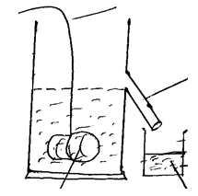
Spout
String
Overflow can
or Eureka can
Irregular object
Displaced water
150c.c
10c.c
5cc

The volume of the irregular object is 10cc.
Weight and mass
Weight
- Weight is the gravitational force exerted on an object by the earth.
- Weight is measured in units called Newtons (N)
- The weight of an object changes as the object moves further from the earth or when put under water because it depends on gravity.
NB: It’s difficult to ride a bicycle uphill because you work against gravit and its easy to ride down hill because of the gravitational pull.
MASS
- Mass is the quantity of matter contained in a body/an object.
- The mass of a body is constant because it doesn’t depend on gravity.
- Mass is measured in units called grammes (g).
- Determine the weight and mass of the sacks below.
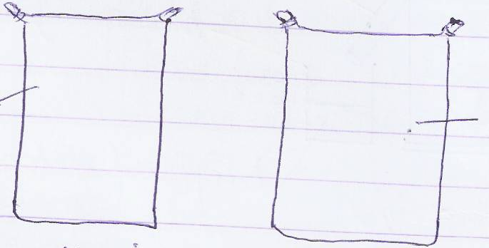
Sack of maize
Sack of cotton

- The maize sack has more weight than the cotton wool sack but their mass is the same because they occupy the same space.
- Mass and weight of an object is measured using the same machines i.e beam balance, spring balance, weighing scale, set of scales and scale balance.
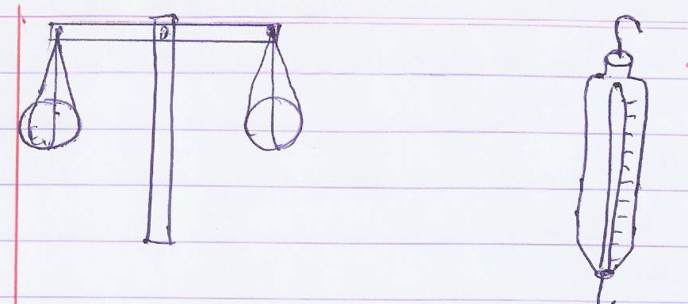
Beam balance Extension spring balance

Set of scales
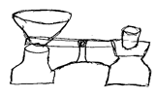

Density
- Density is the mass per unit volume.
- Density is measured in units called grammes per cubic centimeters(glc.c) or grammes per milliliter(glml)
- The density of liquids is measured using an instrument called a hydrometer.
- The density of a substance can be found if we know its mass and volume.
M
D
V
Density = Mass
Volume

- We can also use the triangle above to find the mass and volume i.e
- Volume = Mass
Density
Mass = Density x Volume
Finding the density of objects.
a) Find the density of an object whose mass is 150 and volume is 30cc.
D = m
V
D = 150g
30cc
D = 5glcc

b) If the mass of a cuboid below is 480g. Find its density
4cm
6cm
2cm

In this case, we first find the volume of the cuboid before finding the density.
V = Lxwxh
= (6cm x 2cm)x 4cm
= 12cm² x 4cm
= 48 cm²
Density = m
V
480g
48c.c
= 10glcc
c) Find the volume of a substance whose mass is 120g and density is 30glc.c

V = Mass
Density
V= 120g
30glc.c
V = 4c.c

- Find the mass of an object whose density is 0.25glc.c and volume is 5c.c.
Mass = Density x Volume
= 0.25glx.x x 5 c.c
= 1.25g

Floating and sinking
- Floating is when an object put in water stays on top of the water.
- Objects float on water because they are less dense than water i.e their density is less than that of water.
Examples of objects that float on water.
Boats, ship, feathers, leaves, cork, plastic, pieces of paper, polythene bags, threads, sponge, cotton wool, balloons.
Sinking is when an object put in water goes down to the bottom of water.
Some objects sink because they are denser than water i.e their density is greater than
that of water.
Examples of objects that sink under water.
stones, sand, coins, metallic, objects, glass, nails, bricks, keys, padlocks, cassava, mangoes.
NB: A sinking object displaces the amount of water equal to its volume while a floating
object displaces the amount of water equal to its weight.

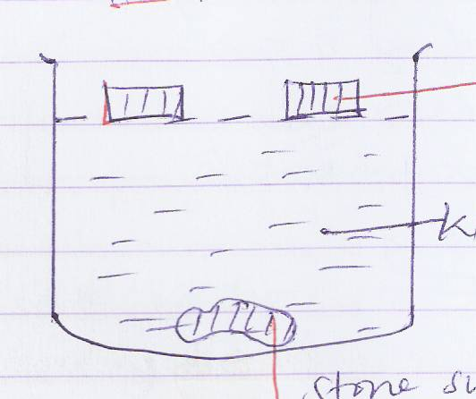Illustration
Water
Cork floating on water
Stone sunk under water

Buoyancy/upthrust is the force which enables an object to float on water.

TOPIC III IMMUNITY AND IMMUNISATION
Immunity is the ability of the body to resist disease causing germs.
Protection of an organism against infections.
Types of immunity
- Natural immunity
- Artificial immunity

Natural immunity
- This is the type of immunity which got from the mother through the placenta.
- It can also be got through breast feeding.
Artificial immunity
This is the type of immunity got after immunisation using vaccines.
This is the best type of immunity because it lasts in your body for the rest of the time after getting it.
Ways of acquiring/getting immunity in our body.
- Through breast feeding.
- Through immunization with vaccines.
- After recovering from a certain disease/getting rid of a certain disease.
- From the mother to a child during pregnancy
- Through having a balanced diet
IMMUNISATION (vaccination/inoculation)
- production of immunity by artificial means
- This is the introduction of vaccines in the body to make it produce antibodies against diseases.
- Vaccines are medicines introduced in the body to make it produce antibodies against certain diseases.
- Antibodies are chemicals produced by the white blood cells to defend the body from disease causing germs.
- Antibodies are defence proteins found in blood plasma
Antigen is a substance that stimulates the production of antibodies e.g virus, bacteria
Types of vaccines
Toxoids, killed or dead vaccines and attenuated living vaccines.
Toxoids - These are made from toxins/poisons produced by bacteria in the body.
These toxins are made harmless before being injected in the body e.g tetanus toxoids
Dead/killed vaccines - These are made after killing grown bacteria and viruses before they are put in our body e.g cholera vaccine and polio vaccine.
Attenuated living vaccines – These are got from bacteria and viruses which have grown in the body of an animal like a cow or horse.
- They are made weaker before being injected in the body of a person e.g BCG Vaccine.
- BCG in full is Bacilli Calmatte and Guerin. It was discoursed by French doctors (bacteriologists) called Calmatte and Guerin.
Note: (UNEPI) Uganda National Expanded Programme on immunization organizes immunization in Uganda.
The eight childhood killer disease/infant killer immunisable diseases.
- They are called infant killer diseases because they mostly kill children below 5 years.
- They attack these infant because their immunity is still weak.
Examples of the eight childhood killer diseases.
- Polio - Tuberculosis
- Measles - Tetanus
- Hepatitis - Whooping cough (pertusis)
- Diphtheria - Haemophilus influenza B
Measles
- It is caused by a virus and spreads from an infected person through air.
Signs and symptoms of measles.
- Red eyes
- Sores on the mouth
- Rash/skin rash all over the body
- Dry cough
Prevention and control of measles
- Immunize children with measles vaccine which is injected on the left upper arm at the age of 9 months.
- Measles is not immunized at birth because the baby is born with natural immunity which lasts for about 9 months.
Poliomyelitis (polio)
- It is caused by a virus passed out by an infected person through faeces.
- It spreads through drinking and eating contaminated water and food respectively.
- The disease affects the limbs (leg and hands) mainly and the skeletal system causing lameness/crippling of a person.
Signs and symptoms of polio
- Paralyzing of body muscles.
- Weakness of bones especially in limbs
- Lameness.
Ways of preventing and controlling polio.
- Boil drinking water and keep food covered.
- Use latrines for proper disposal od human wastes.
- Wash fruits and vegetables before eating.
- Wash hands before eating and after using latrines.
- Through immunization using the polio vaccine by giving three drops of the vaccine the mouth.
- This method is called oral administration/oval method.
- The first doze is given to a baby at birth and it is called Polio O flowed by Polio 1, Polio 2 and Polio 3.
- The four doses are given at an interval of one month from the previous one.
- There two types of polio vaccine i.e salk and sabin. Salk is injected while sabin is given orally. In Uganda sabin type is commonly used.
- Polio vaccine is given at birth because the baby isn’t born with any immunity against polio.
Tuberculosis
- It is caused by bacteria called myco- bacterium.
- This bacterium was first discovered by Robert Koch in 1882.
- There are many types of myco-bacteria i.e mycobacterium tuberculosis which causes T.B of the lungs and mycobacterium bovis which causes T.B of the alimentary canal and skeletal system.
- Tuberculosis of the lungs is spread through air after coughing or sneezing of an infected person.
- Tuberculosis of the skeleton is spread through drinking un boiled milk from an infected cow (tuberculosis cow).
NB: Always boil milk to kill germs before drinking and cover your nose and mouth with a hankie when sneezing and coughing.
Signs and symptoms of tuberculosis.
- Chronic/persistent cough
- Loss of body weight
- General body weakness
- Coughing and spitting mucus containing blood stains.
- Persistent fever.
- Pain in the bones, joints and back bone.
Ways of preventing and controlling tuberculosis.
- Avoid drinking un boiled milk.
- Always cover your mouth and nose with a hankie when sneezing and coughing.
- Isolate infected persons.
- Treat infected persons in recognized hospitals because the treatment is free in government hospitals.
- Immunize children using BCG vaccine which is injected on the right upper arm at birth.
Note: Some one can tell that you were immunized against T.B by checking the immunisation scar on the right upper arm.
Tetanus
- It is caused by bacteria which live in the soil for several years.
- It spreads through cuts and wounds on the body.
- In new born babies, the bacteria enter through the umbilical cord if it is cut using unsterilized blades.
Signs and symptoms of tetanus
- Stiff muscles all over the body.
- Spasms when touched.
- Difficult in swallowing thus the baby stops sucking.
Prevention and control of tetanus.
- Immunization using the DPT vaccine which is given to a baby at six weeks in three doses i.e weeks, 10 weeks, and 14 weeks.
- The vaccine is administered by injection on the left upper thigh.
- Girls and women between 15 years – 45 years are given tetanus toxoid (TT) vaccine to protect their unborn babies from getting tetanus.
- All pregnant women and accident victims get T.T vaccines.

WHOOPING COUGH (PERTUSIS)
- It is caused by bacteria and spreads through air after coughing and sneezing of infected persons.
Signs and symptoms of pertusis
- Difficult breathing/gasp for breathing.
- Coughing which ends up in vomiting.
- Runny nose.
Prevention and control of pertusis.
- Immunize children using the DPT vaccine.
Diphtheria
- It is caused by a bacteria and spread through air.
Signs and symptoms of diphtheria.
- Swollen neck
- Sore throat
- Difficult breathing
- Severe fever
Prevention and control of diphtheria
- Immunize children with the DPT vaccine starting at 6 weeks.
- DPT is called a triple vaccine because it treats three diseases i.e Diptheria, Pertusis and tetanus.
Hepatitis B
- It is caused by hepatitis B virus (HBV) which lives in body fluids and blood of an infected person.
- The disease mainly affects the liver leading to cirrhosis and liver cancer.
- It can be spread through sexual intercourse and sharing sharp piercing objects with infected persons.
- It can also be spread through blood transfusion and unsafe injections.
- In children it can be spread through suts at birth if the mother is infected.
Signs and symptoms of hepatitis B.
In children, it shows no sign but can live in the body for several years.
In adults it shows the following signs and symptoms.
- Yellow skin in palms and feet.
- Yellow eyes
- Los of appetite.
- Vomiting and body weakness.
- It can cause sudden death if not treated early.
Prevention and control of hepatitis B
- Immunization of children below one year using a combined DPT and Hep B vaccine given in three doses.

Haemophilus influenza B
- It is caused by bacteria and spreads through air after coughing and sneezing of infected persons.
- It can also be spread through speaking closely with infected persons.
- In children, it can be spread through sharing playing materials like toys put in the mouth of one child to another’s mouth through saliva.
- The disease causes a fatal brain infection in children.
Signs and symptoms of HIB disease
- Swelling in brain membrane (membranes cover the brain and spinal cord)
- Fever
- Weakness of the body
- Vomiting
- Stiff neck
Effects of HIB disease
- It causes severe meningitis
- It can cause brain damage and death.
- HIB leads to mental retardation, deafness and speech problems if not treat early.
Prevention and control of HIB disease
- Through immunization with HIB vaccine which is combined and given together with DPT and Heb vaccine on the left upper thigh starting from 6 weeks.
- Treat infected children using antibiotics called rafampin to kill the bacteria.
Immunization sites on a baby
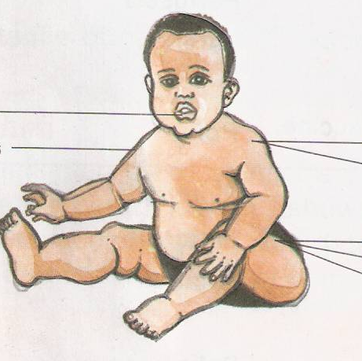
Left Upper Arm (Measles vaccine)
Left Upper Thigh
DPT + Heb+ Hib Vaccine

BCG Vaccine
Right Upper Arm

Mouth (Polio Vaccine)

Immunization site and schedule.
Age | Vaccine | Disease | Mode of administration | Site
At birth | BCG vaccine | Tuberculosis | Injection | Right upper arm
 | Polio vaccine | Polio | Putting three drops in the mouth/oral method | Mouth
6 weeks | Polio 1 Vaccine | Polio | Oral method | Mouth
 | DPT 1 Vaccine | Diphtheria, Pertusis, Tetanus | injection | Left upper thigh
10 weeks | Polio 2 vaccine | Polio | Oral method | Mouth
 | DPT 2 vaccine | Diphtheria, Pertusis, Tetanus | Oral method  Injection | Left upper thigh
14 weeks | Polio 3 vaccine | Polio | Oral method | Mouth
 | DPT 3 vaccine | Diphtheria, Pertusis, Tetanus | Injection | Left upper thigh
9 Months | Measles  Vaccine | Measles | Injection | Left upper arm.
Girls and women between 15 -45 years. | Tetanus /Toxoid vaccine (TT) | Tetanus | Injection | Left upper arm.

Importance of immunization
- It protects children against the 8 killer diseases.
- Immunization boosts the immunity of children and adults.
- It reduces the death rate of young children.
- Immunization enables the body to produce more antibodies.
Roles of individuals, families and community in immunization
a) Individuals
- Sensitizing people about the importance of immunization.
- Inform other people in an area about immunization.
- Educating people about the importance of immunization on radios and TV programmes.
b) Family
- Ensure that all children at home are immunized.
- Taking their children to health centres for immunisation.
c) Community
- constructing of health centres in the community.
- Organize seminars, workshop and plays about immunisation.
- Educating and sponsoring community health workers.
Other immunisable diseases apart from the killer diseases.
- Cholera, meningitis, small pox, typhoid
- Yellow fever, rabies, influenza, plaque, German measles.

Child Health Card
This is a car which contains information about a specific child.
Contents of a Child Health Card
- Child’s name - Sex of the child
- Mother’s name - Mother’s occupation
- Date of birth - Dates of immunization
- Father’s of name - Father’s occupation
- Place of residence - Birth order in the family
- Birth weight
Importance of a Child Health Card
- It helps parents to remember the dates of the next.
- It helps parents and doctors to monitor the growth of a child.
- Helps parents to remember the birth day of children.
- Helps doctors to know if the child completed all the doses.

Ways of identifying if a child was immunized
- Checking on the child’s health card
- Checking the immunisation scars on the site of immunisation

TOPIC IV THE DIGESTIVE SYSTEM
The digestive system is a group of body organs which break down food into small soluble particles.
The alimentary canal is a muscular tube running from the mouth to the anus through which food passes.
The alimentary canal is 30 ft or 10 metres long.
DIGESTION
- Digestion is the process by which insoluble food is broken down into small soluble particles that can be absorbed in the body.
- Digestion of food begins from the mouth and ends in the ileum.
Types of digestion
a) Mechanical digestion / Mastication
– This is the breaking down of food into small particles by the teeth.
- Mechanical digestion occurs in the mouth.
b) Chemical digestion
This is where food is broken down into small soluble particles by enzymes.
Enzymes - These are chemical compounds which speed up digestion of food.
Characteristics of enzymes
- They are destroyed by heating.
- Hey always form end products.
- They act on only one kind of substances.
- They work best in specific conditions i.e acidic and alkaline.
- They are protein in nature

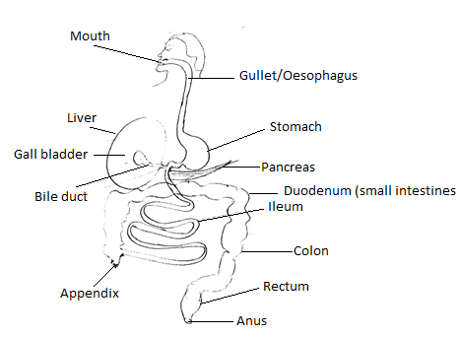
Diagram showing organs of the digestive system.

Digestion in the mouth
- The mouth has teeth which help to break down food into small particles.
- It has saliva which is produced by the salivary glands.
- Saliva helps to lubricate and soften food before it is swallowed.
- Saliva contains an enzyme called salivary amylase or ptyalin which starts the digestion of carbohydrates and cooked starch in the mouth.

- The mouth also has a tongue which helps to turn and roll food into bolus before swallowing.
Digestion in the gullet.
- The gullet is a passage of food from the mouth to the stomach.
- During swallowing, the epiglottis closes the opening of the windpipe to prevent food particles from entering which may cause choking.
- Food posses through the walls of the gullet and the whole alimentary canal by the process of peristalsis.
- Peristalsis is a wave like contraction of the alimentary canal which pushes food through it.
Digestion in the stomach
- Food is stored in the stomach for about 3 hours.
- It is thoroughly churned or turned over and over into chyme.
Chyme is semi-digested food passes from the stomach to the duodenum
- The walls of the stomach produces a juice called gastric juice and an acid called hydrochloric acid.
- Gastric juice contains two enzymes Pepsin and Rennin.
- Pepsin digests proteins in the stomach while Rennin clots proteins in the milk in children.
NB: Digestion of proteins starts in the stomach.
Hydrochloric acid helps to kill germs which escape with food during swallowing.
- It also provides the acidic conditions for proper working of Pepsin enzyme.
- The walls of the stomach also help to absorb alcohol, medicines and salts.
Digestion in the Duodenum
- The duodenum is a U-shaped organ and it’s about 25cm long.
- It receives bile through the bile duct.
- Bile is a green liquid produced by the liver and it stored in the gall bladder.
- Bile contains salts which help to break down fats into tiny particles/droplets.
- The duodenum is also connected to the pancreas.
- The pancreas produces a juice called pancreatic juice.
- Pancreatic juice contains three enzymes i.e Lipase which digests fats, Trypsin which digests proteins and Amylase which completes digestion of carbohydrates began in the mouth.
NB: Fats are first digested in the duodenum.
Digestion in the ileum
- The walls of the ileum produces a juice called intestinal juice.
- This juice contains four enzymes i.e Maltase, Sucrase, Lactase and Erepsin.
- The above enzymes help to complete the digestion of food i.e, digestion of food ends here.
- Absorption of digested food takes place in the ileum.
Absorption - Is the process of taking digested food into the blood stream.
- After absorption, the hepatic portal vein carries blood containing digested food from the ileum to the liver.
Adaption of the ileum for its function.
- It has finger like structures called villi.
- It is very long to give a large surface area for food absorption.
- It is surrounded by a sense network of blood capillaries which carry away absorbed food.
The Colon
- Absorption of water takes place here.
- No digestion of food takes place here because there is no enzyme produce in the colon.
Rectum
- Undigested food is stored here before it is passed out.
- The longer the undigested food stays in the rectum, the harder it becomes.

Anus
- It’s an opening where undigested food is passed out of the body as stools or faeces.
- Faeces contain the following, water, roughages, bacteria, mucus and dead cells.
NB: Vitamins and mineral salts are not digested because they are already soluble.
Diseases of the digestive system.
a) Peptic Ulcers - These are wounds/sores in the stomach, duodenum nd ileum.
b) Appendicitis - This is a swelling of the appendix caused by germs.
- Some one feels a lot of pain in the lower abdomen and can cause
death id it bursts.
- It can be controlled by surgery.
c) Cholera, typhoid, diarrhea and dysentery, Hepatitis E.
Disorders of the digestive system
i) Constipation
- This is a condition when someone passes out very hard stools or takes long to pass out stools.
- It is caused by lack of roughages in the diet.
- It is controlled by eating foods containing roughages.
ii) Indigestion
- This is when food is not digested properly.
- It is caused by improper chewing and eating hurriedly, failure to drink water.
- Indigestion can be controlled by chewing food well before swallowing, drinking enough water after eating and avoid eating hurriedly.
iv) Vomiting and diarrhea doesn’t last for three days.
Ways of caring for the alimentary canal.
- Wash hands before eating food and after visiting latrine.
- Chew food properly and slowly.
- Eat food containing a balanced diet.
- Have regular meals.
- Eat well cooked food for easy digestion.
- Have regular physical exercises.

